**JAWAN PAKISTAN**

**NAME :SYED OBAID ULLAH HASHMI**

**Roll NO:KWOWFL1165**

Assignment 4

**1) Install Flutter, make a project by “Flutter create projectname” and then run app by “flutter run”**

**and take screenshot.**

OUTPUT:

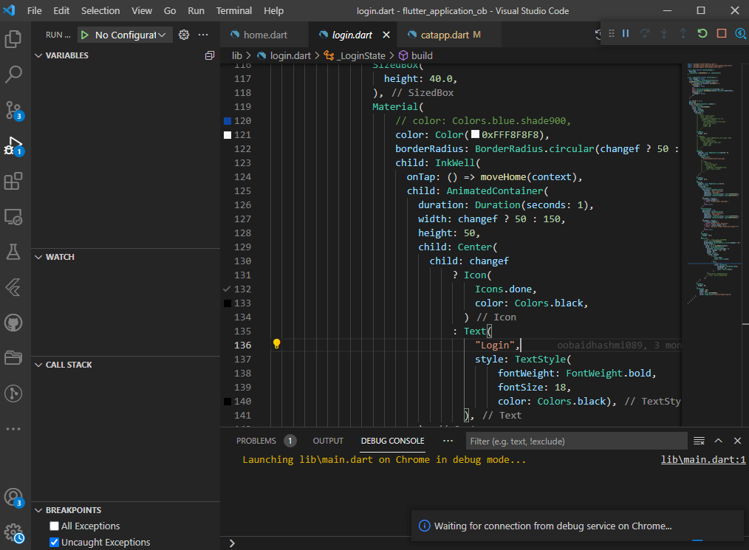

**2) To make a function that take a number as parameter, and print the table of that number.**

CODE:

**//Q2**

num table(a)

{

for (int i =1;i<=10;i++)

{

print("${a} X ${i} = ${a*i}");

}

return 0;

}

void main()

{

table(2);

}

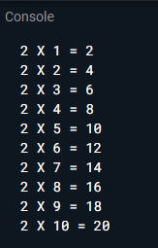

**3) List lst = [2,4,6,8,9];**

**Make a function that takes a number as parameter and divide that parameter to every element**

**in the list**

CODE:

void numbers(num b)

{

List lst = [2,4,6,8,9];

var a;

for (int i =0;i<lst.length;i++)

{

a =lst[i]/b;

print(a);

}

}

void main(){

(numbers(3));

}

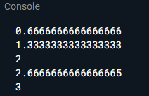

**4) Make a function for printing mark sheet then Make a list of at-least 5 names and another list of**

**their marks, and print the mark sheet of all of them.**

CODE:

void student(){

var lst1 = ["obaid1","obaid2","obaid3","obaid4","obaid5"];

var lst2 = [55,66,77,89,99];

for(int i =0;i<lst1.length;i++)

{

print("NAMES");

print(lst1[i]);

for(var j=0;j<lst2.length;j++){print(lst2[j]);}

}

}

void main()

{

student();

}

**5) Make a function in class and then call it outside class.**

CODE:

class A{

void b()

{

print ("Hello");

}

}

void main()

{

A c=new A();

c.b();

}

**6) Print your name in a sentence using classes.**

CODE:

class F

{

void l(){

print("My Name is ");

}

}

class Name extends F

{

void e(){

String a = "obaid";

print(a);

}

}

void main()

{

Name c=new Name();

c.l();

c.e();

}

**7) Make a constructor that requires your name, age, education and then print that.**

CODE:

class Info{

var name ;

String age ;

var education;

Info(this.name,this.age,this.education)

{

print("Name is "+name);

print("Name is "+ age);

print("Name is "+education);

}

}

void main ()

{

Info c=new Info("obaid","12","Inter");

}

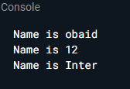

**8) Write a Code using inheritance**

CODE:

class F

{

void l(){

print("My Name is ");

}

}

class Name extends F

{

void e(){

String a = "obaid";

print(a);

}

}

void main()

{

Name c=new Name();

c.l();

c.e();

}